Distance Vetor Routing

1. Select the Input file

You can select the input file by clicking the file open button in GUI. Then open the file dialog and select the input text file.

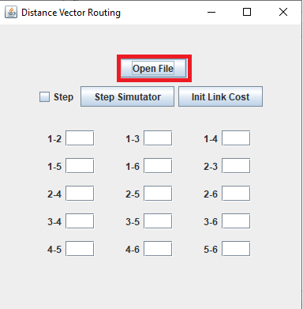

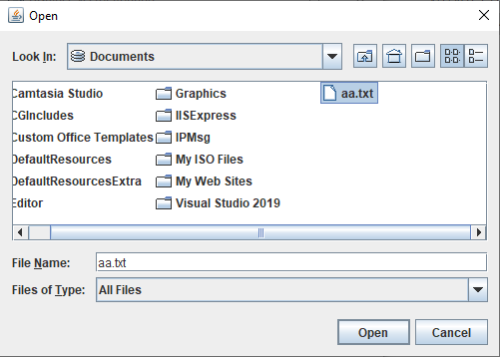

1. Initial link state tables set up in GUI

When you input the file, link cost values are displayed in GUI .

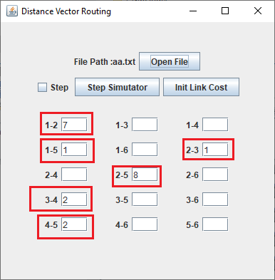

In here, “1-2” means route 1 and route 2 and “7” means link cost value between route 1 and route 2.

1. System detects a stable state

You can run the app and view the result in different route window.

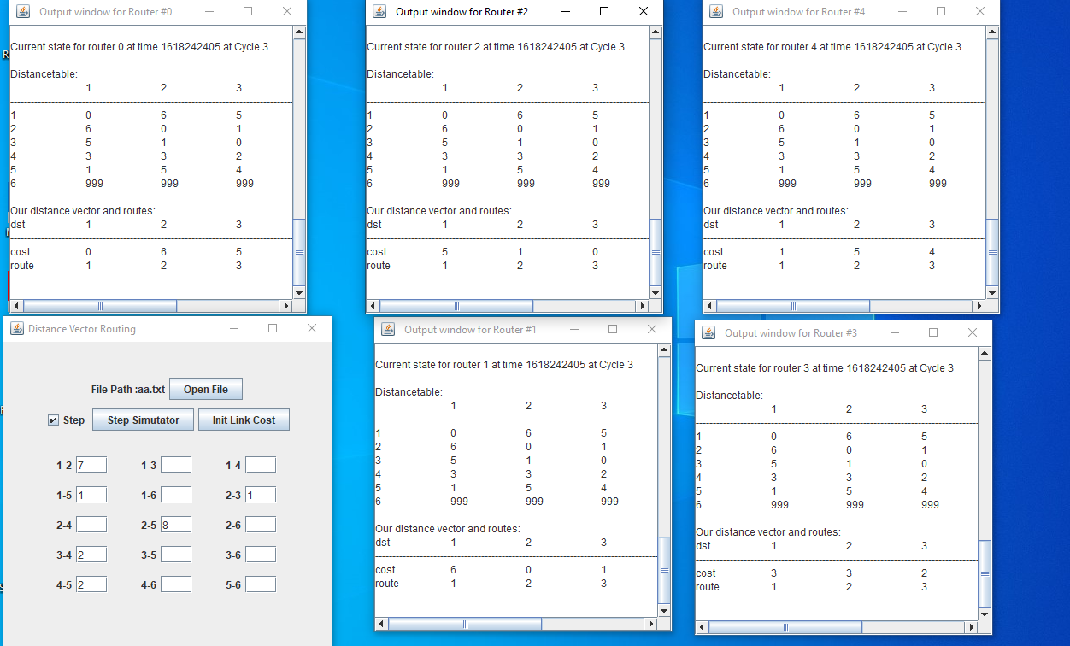

If you select the “Step” checkbox with check and click “Step Simulator” button, run the app by step. And deselect the “Step” checkbox, run the app without intervention. When the app run without intervention and find the stable status, displays time and cycle.

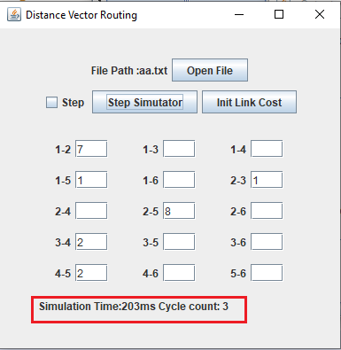  
When you change the link cost values and click “Step Simulation” button, you can get the other result for changed link cost values.

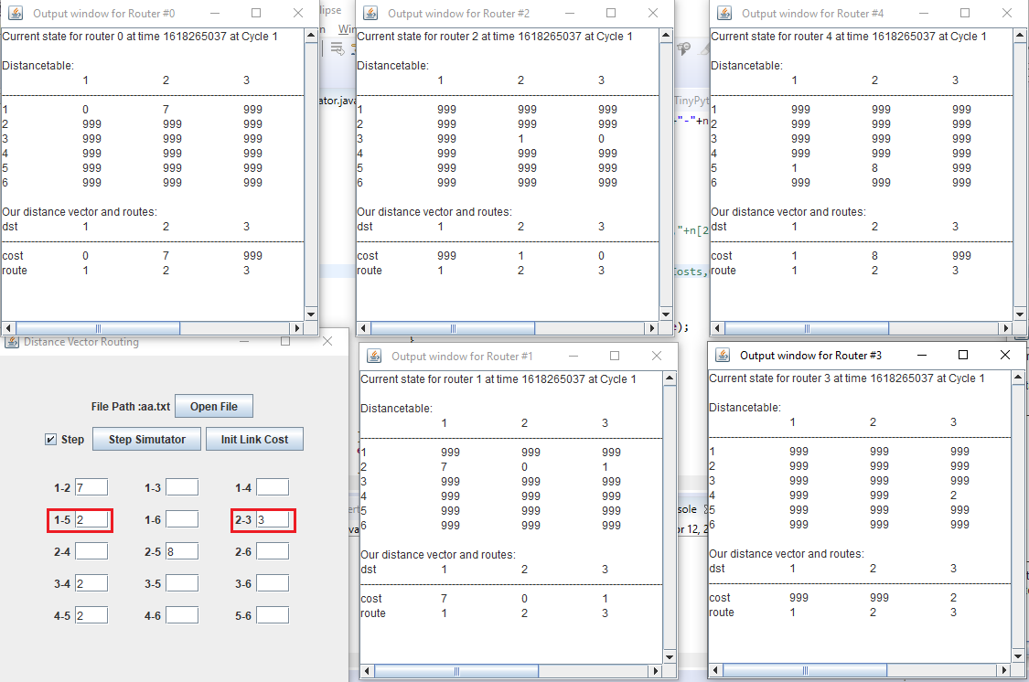

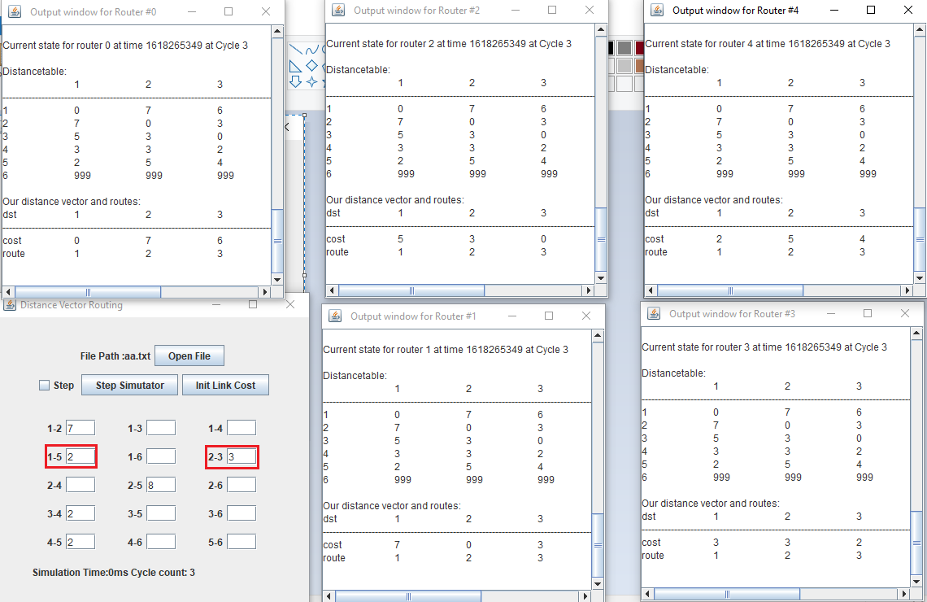

You can initialize the link cost values by clicking the “Init Link Cost” button and simulate the distance vector routing.